Process Improvement Flowchart

As-Is Process Flow Chart Evaluation

McDonald’s Store Ordering Process
Student’s Name
Institutional Affiliation
Tutor
Date

Select a process from an organization you work for or are familiar with. You will use this process in your Week 2 & Week 4 Signature Assignments as well.
Create a flowchart of the as-is process using Microsoft Word, PowerPoint, Vizio, or Excel.
McDonald’s Store Ordering Process
From the instance of ordering in the McDonald’s store, the simplified store space gives a decent way that can be used in explaining main ideas, which could be related to the cardboard wall and in the exploration of the agile methodology.
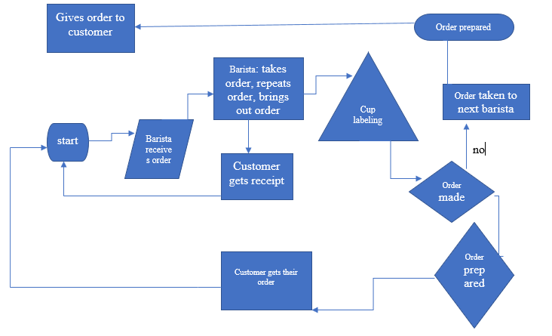
Evaluate the efficacy of your process using process improvement techniques.
The overall outlook of the process is designed to deliver the value to the customer. Who is the main player in the overall set up of the store and is the recipient of the process output. From the interaction of the customer, the overall expectation of the customer, the needs or the desires are met in relation to the products offered in the store. Thus, the process requires minimal improvement.
The process has been designed and developed by paying close attention to the needs of the business. However, with the current market dynamics, the firm is slightly coming short of the competition due to the low current process performance. This provides a focal point that the process flow chart needs to be redesign to realign it to the current business dynamics and needs (Eboigbodin, 2016).

Process Improvement Flow Chart
Determine how the process can be improved based on the results of your evaluation.

Define metrics and measure the current process.

How the process can be improved
Processes optimization is the major way the ordering process can be improved in the store. This will allow the designing and the realignment of the process is done by understanding the problems faced before offering the solution. The needs of the buy in customers’ needs to be established before adopting any form of changes.
Metrics and measure of the current process
McDonald’s Store is a profit driven outfit. This has led to the management pursuing strategic management accounting measures. These metrics includes analysis of the store value chain, cost optimization and conducting industrial benchmarking. The metrics and measures adopted are more market oriented which plays a major role in optimizing the firm’s revenue model.
Also, service excellence forms an x-factor of the store; the process is designed to meet the traditional criteria observed. New designs and realignment offers spokes to the traditional processes and revitalize the overall operations gained from the metrics. Thus, service excellence is used in exemplifying a holistic approach of the store operations and performance evaluation (Pratama, 2019).
Use process improvement techniques to improve the process. Create a flow chart of the improved process using Microsoft Word, PowerPoint, Vizio, or Excel. Use your professional judgment to ascertain how the future process will perform according to your metrics.

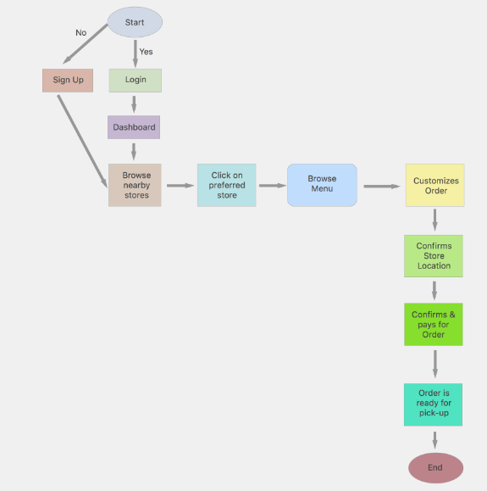

Summary
Write a 525-word executive summary that includes the following:
- A brief description of the process based on the flowchart of processes current state
- The results of your process evaluation and how the weak points can be strengthened. Include a description of the process improvement technique(s) used.
- A brief description of process improvements based on the process of the future state
- How you anticipate the future process will perform based on metrics used to evaluate process current state
- A description of your process improvement project to achieve the process future state

Process description
The following are some of the processes that are involved in coffee ordering at McDonald’s. The firm has modeled its operations basing on the stages a single customer undergoes. For this instance, we consider the stages undergone by ‘customer A’.
Written account queues
When the ‘Customer A’ gets to the store, he encounters other customers queuing in the register. Basing on the former experiences and encounters, he joins the line and believes that no matter the line, he will get served. The customer infers currently in support of the number of other customers that came before him.
Register
When ‘Customer A reaches the register, he/she places their coffee order. An empty cup is put at the realm between the barrister and the register.
Customer waits for the barrister
The empty cup market with the details of the customer order is given to the barrister for the completion of the order of ‘Customer A’. The cups are put in order with the time the order is given, however, the barrister can jump customer lines in case of the column up queue is being observed.
Barrister
‘Customer A’ has to wait for the barrister to complete the orders placed a head of him. The barrister will read the label on the cup of ‘Customer A’ and prepares the coffee order ordered.
Order ready
Once ‘Customer A‘ hears their name called out, or identifies his marked cup on the counter, they can collect their coffee. Normally, ‘customer A’s’ coffee is erroneously ready with soy milk instead of milk. in such an instance, ‘customer a’ returns the order to the barrister for the right order to be prepared and an apology given to ‘customer a’.
Evaluation results and improvements
From the evaluation of the processes, the overall performance of the process is efficient in use. However, given the evolution and the dynamics of the market, technological growth and other social factors such as the outbreak of Covid19, most operations have been transferred to digital platforms which are a shortcoming of the current operation process. Thus, there is need to incorporate the current dynamics and improve the process further and ensure that efficiency is achieved in the firm (Tarapituxwong, Tantranon, & Duangpatra, 2015).
Incorporation of digital ordering makes it simple and gives the barristers an ample time to ready the order before the customers comes for picking.
The future process is designed to improve operation efficiency, reduce the number of customers present in the store physically and reduce the minimum time required to complete the order. Also, digital ordering will ensure that possible misunderstanding of the order requirement is minimized.
The new operation process is largely based on the digital incorporation to the system. It forms the basic structure that addresses the needs of the customers, the market and meets social needs to regulate possible infections (Cintya & Siahaan, 2020). The optimized system will improve on management and ensure profitability of the firm through the current and potential future unprecedented times. When critically analyzed, the new framework is customer centric with the main aim being meeting the needs of the customer in the shortest time possible.

Reference
Cintya, C., & Siahaan, R. F. (2020). Implementation of the Client-Server System for Ordering Food and Beverages with the Android Platform Using the Waterfall Method (Case Study: Maxx Coffee Prima Ap Kualanamu Store). Journal of Intelligent Decision Support System (IDSS), 3(3), 31-39.
Pratama, K. L. (2019). STANDARD OPERATING PROCEDURE IN COUVEE COFFEE USING MATERIAL REQUIREMENTS PLANNING APPROACH (Doctoral dissertation, Universitas Islam Indonesia).
Eboigbodin, L. (2016). Redefining and mapping of an order to cash process in Company X.
Tarapituxwong, S., Tantranon, N., & Duangpatra, C. (2015). Production process improvement using value stream mapping: a case study of organic coffee firms in Thailand. FEU Academic Review, 8(2), 128-128.

